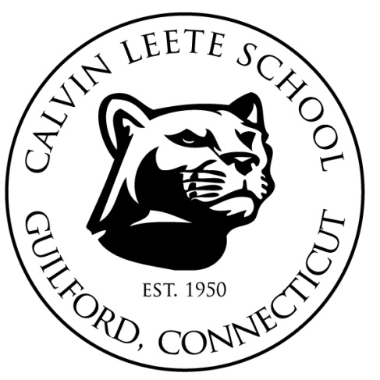
CALVIN LEETE PTO • 280 S. UNION ST. • GUILFORD, CT 06437 •

January 2019

Dear Local Business Owner,

We are writing on behalf of the Calvin Leete School PTO, in Guilford, CT, to request a donation for our annual Art and Silent Auction. The event will be held on Friday, March 15th.

The Art Auction is our PTO’s primary fundraiser for the year, and money raised at this event enables the PTO to fulfill its mission of enhancing the academic experience for Calvin Leete’s280 students in grades K - 4. This year, funds are critical to our work in funding field trips, enrichment events, supplies for our teachers, and playground repair.

In addition to supporting this important work, your tax deductible gift also becomes a great marketing vehicle, providing exposure to your good will (and goods and services) at the event itself, and promoting your business through emails, flyers and other materials reaching the entire Calvin Leete community leading up to, at, and after the event.

We would greatly appreciate any donation that you can offer!

On behalf of the students, parents, and faculty of Calvin Leete School, we thank you for your time and consideration. I look forward to hearing from you!

Sincerely,

Audrey Barr and Kim Vigliotti, Silent Auction Coordinators

Audrey Barr |a1davey@hotmail.com | (347) 675-6704
Kim Vigliotti |kimvigs@yahoo.com | (203) 214-8453

TAX ID 45-537-8100

